Time period | Events | Iconic Image | Music | Art & Architecture | Film
1930s
1950s
1970s
1990s

EVENTS | ICONIC IMAGE | MUSIC | ART and ARCHITECTURE | MOVIE
European Union formed  BBC debuts Television service  Joseph Stalin dies  Pol Pot regime in Cambodia  Sputnik launched  The Great Depression  Hindenberg explosion  Pope John Paul II elected  “War of the Worlds” broadcast  Xerox machine introduced  Univac – first business computer  Queen Elizabeth II accession  USSR breaks up  IBM introduces floppy disk  Nelson Mandela elected South Africa president  Dolly – first cloned sheep  Adolf Hitler appointed German Chancellor  Kosovo war  First email sent across network  Margaret Thatcher becomes British Prime Minister | 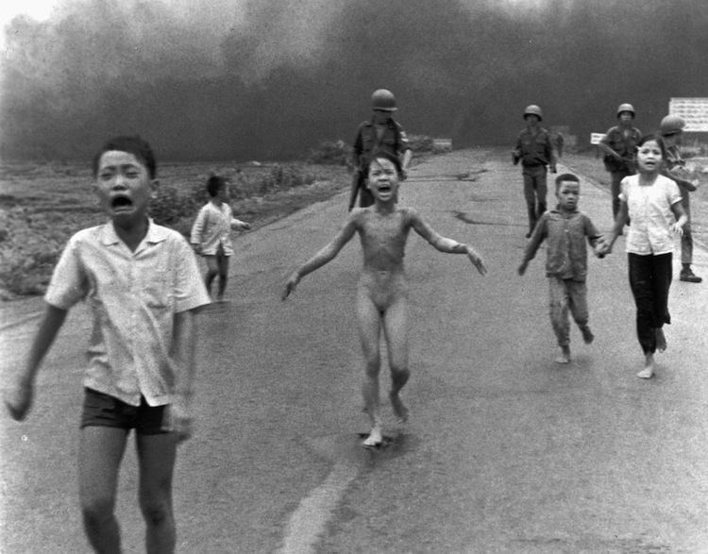       | Nirvana – Smells like teen spirit  https://www.youtube.com/watch?v=hTWKbfoikeg  Elvis Presley – Don’t be cruel  https://www.youtube.com/watch?v=ViMF510wqWA  Bruce Springsteen – Born to run  https://www.youtube.com/watch?v=IxuThNgl3YA  Glenn Miller – In the Mood  https://www.youtube.com/watch?v=_CI-0E_jses | Grant Wood – American Gothic  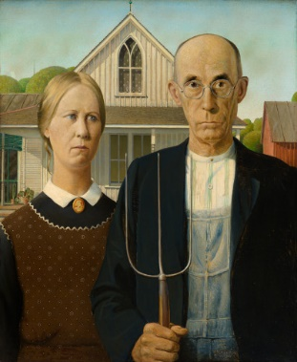  Frank Ghery – Guggenheim, Bilbao  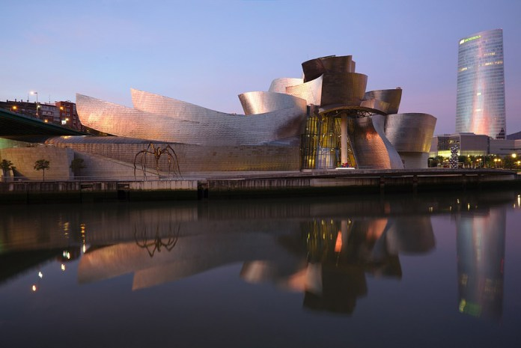  Jackson Pollock – Autumn Rhythm  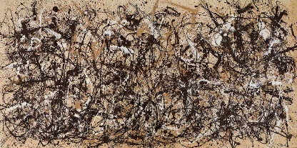  Marina Abramovic  https://www.youtube.com/watch?v=xTBkbseXfOQ | Gone with the wind  The usual suspects  Star Wars  Some like it hot

